School Name
Mathematics Test 2017
Year 7 |  | Angle Properties | Non Calculator  Section
Skills and Knowledge Assessed:  - Use the language, notation and conventions of geometry.  - Recognise the geometric properties of angles at a point.  - Identify corresponding, alternate and co-interior angles when two straight lines are crossed by a transversal (ACMMG163)  - Investigate conditions for two lines to be parallel and solve simple numerical problems using reasoning (ACMMG164) |  |  | Name___________________
Answer all questions in the spaces provided on this test paper by:
Writing the answer in the box provided.
or
Shading in the bubble for the correct answer from the four choices provided.
Show any working out on the test paper. Calculators are not allowed in this section.
A protractor and ruler are needed for this test.
 | Use a protractor to help draw and label an angle STU, which measures 38º.
 | 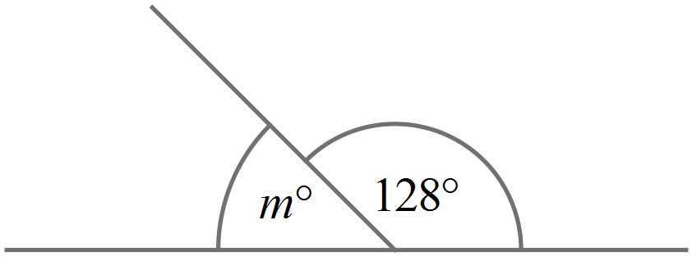What is the value of 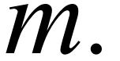
 | 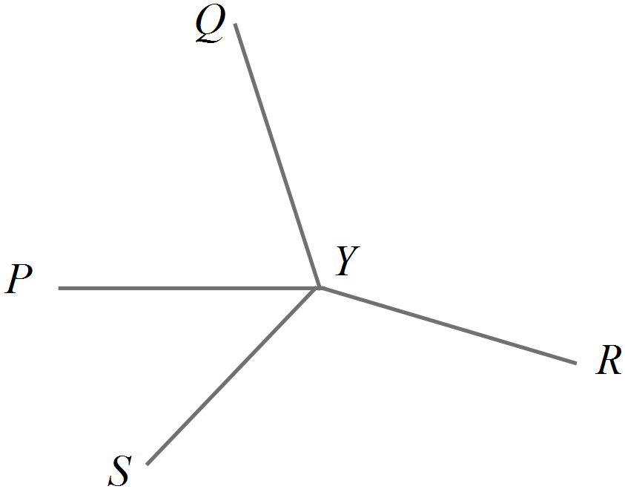Name one of the angles which is adjacent to 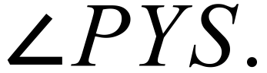
 | 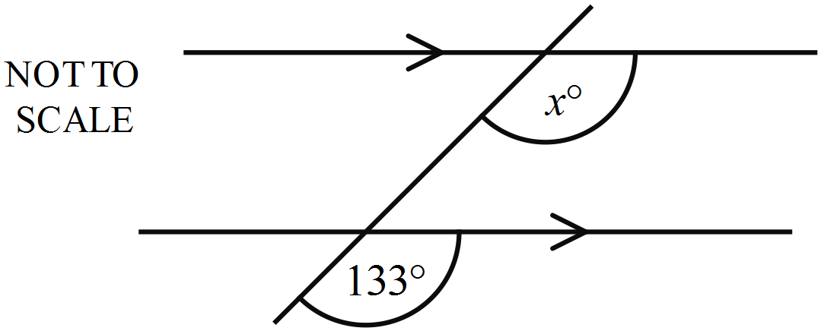What is the value of x?
Use a protractor measure 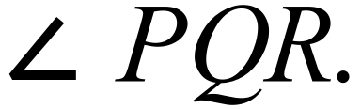
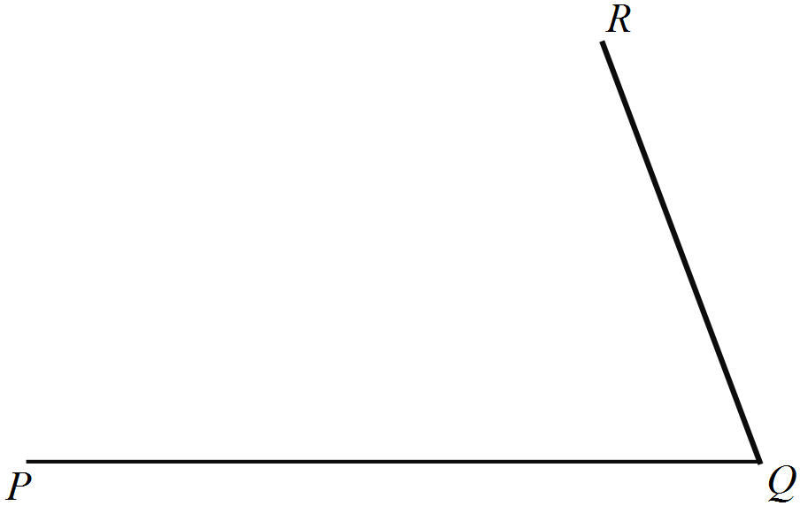

 | Which is true?
What is the supplement of 85º?

5º 85º 95º 105º
Name a pair of perpendicular lines in the diagram.
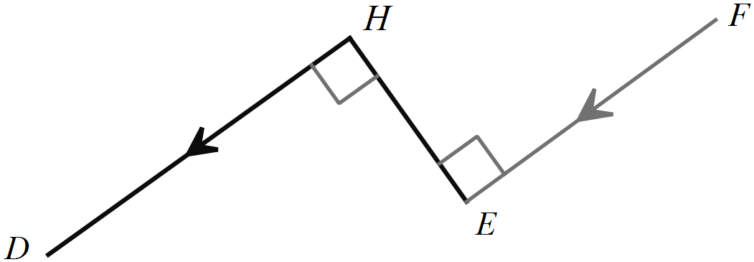

and

 | Use a protractor to help draw and label an angle LMK, which measures 138º.
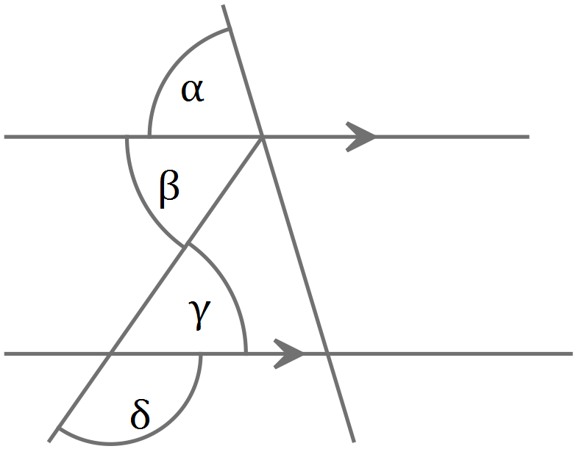Which is a pair of equal angles in the diagram below.

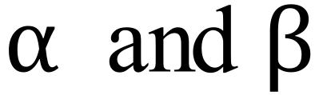
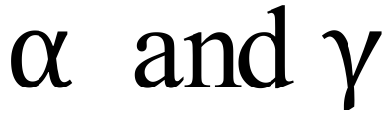
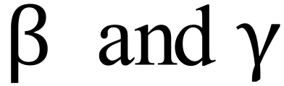
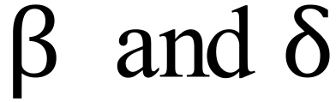

Which reason could be used to determine the value of w?
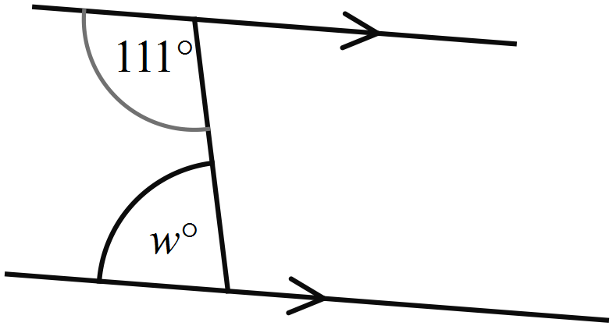

Equal alternate angles on parallel lines.
Equal corresponding angles on parallel lines.
Supplementary alternate angles on parallel lines.
Supplementary cointerior angles on parallel lines.
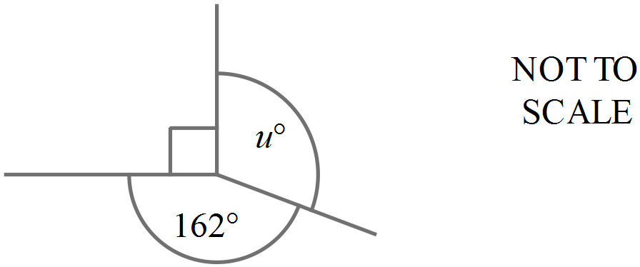What is the value of u?
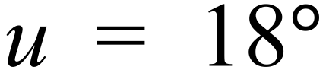
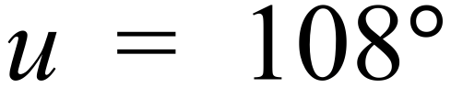
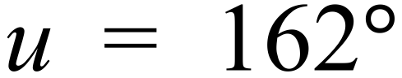
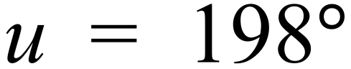
 | 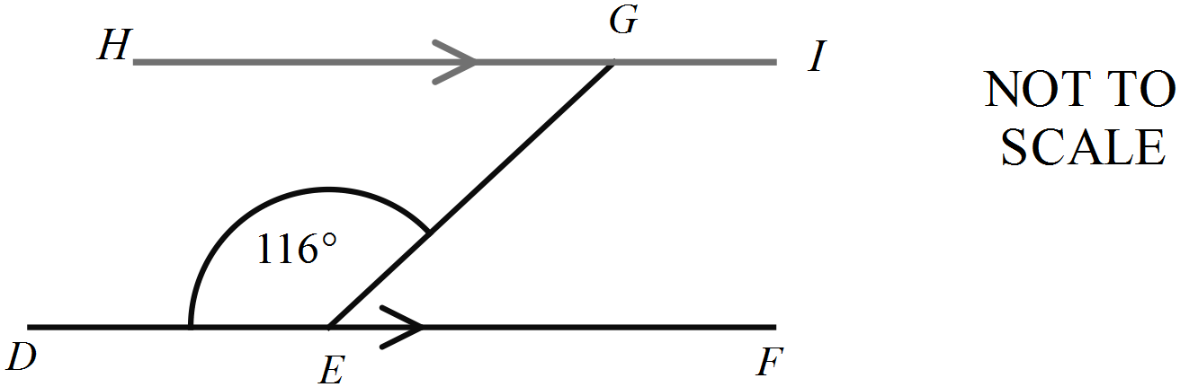What is the size of 
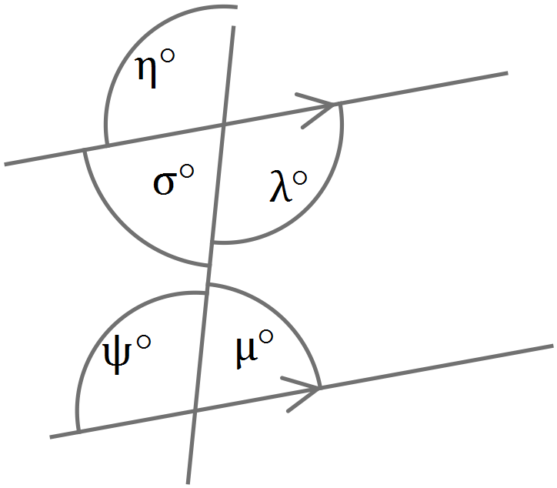Which is not a pair of supplementary angles on the parallel lines shown?

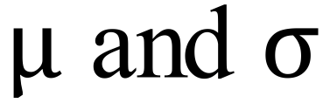
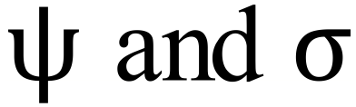
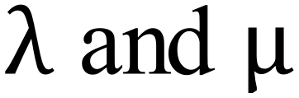
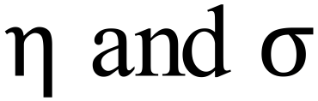

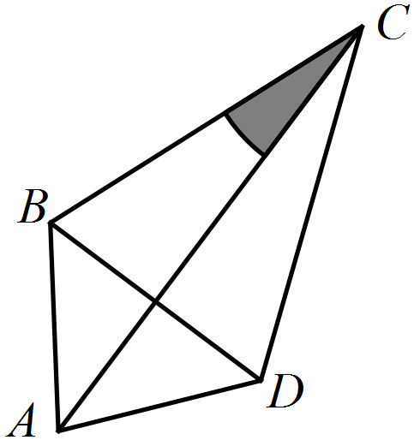How could you describe the shaded angle?





 | 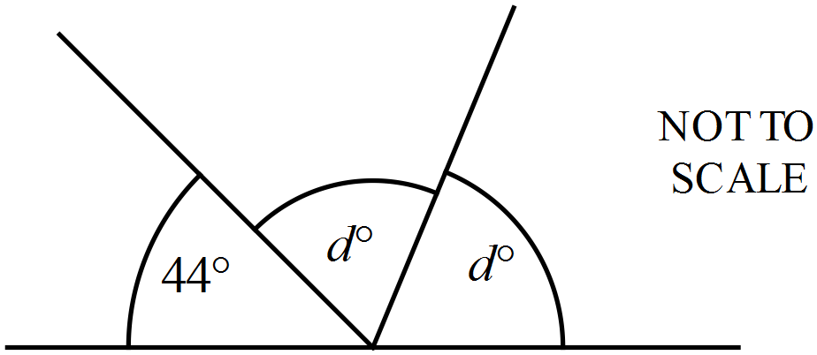
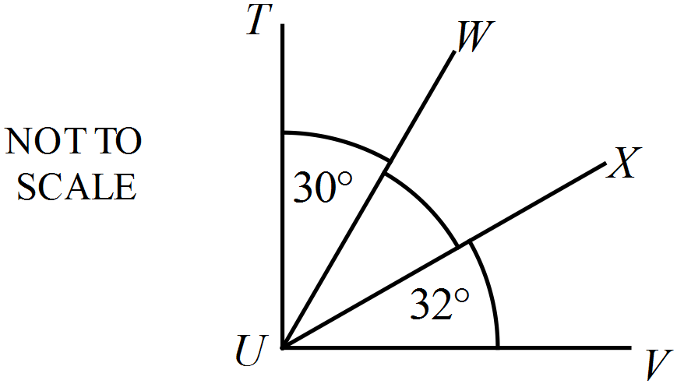
What is the size of 

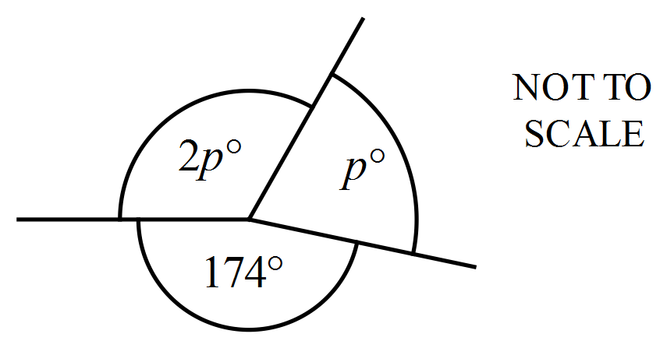What is the value of p?

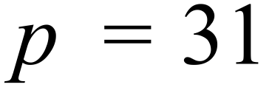
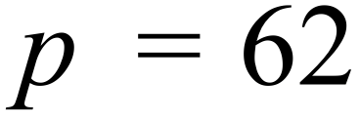
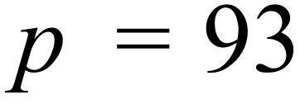
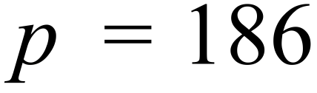
 | 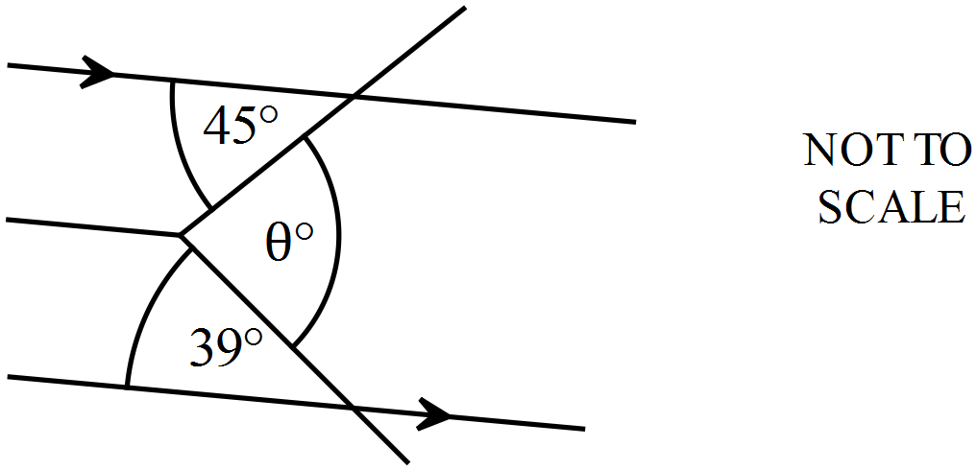What is the value of 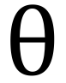 ?
What is an expression for the shaded angle?
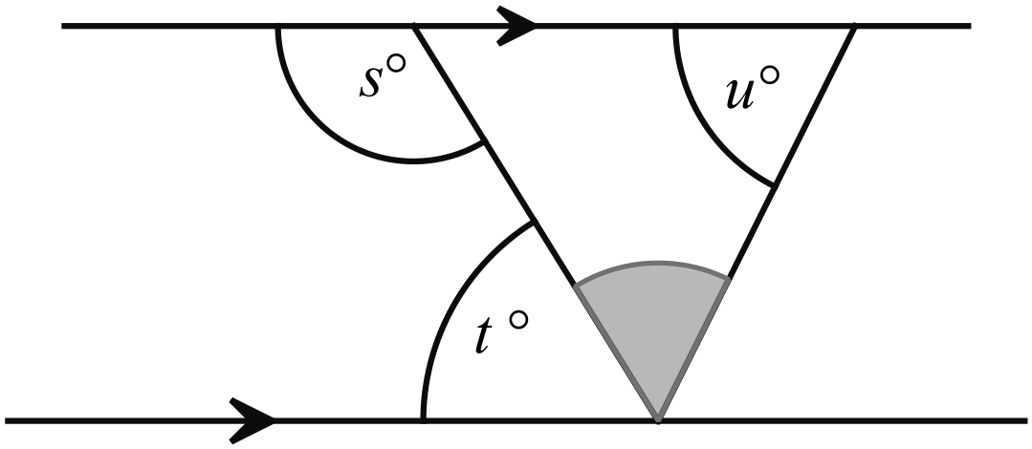
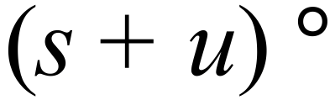
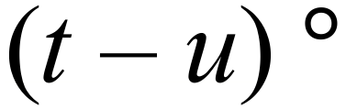
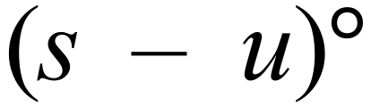
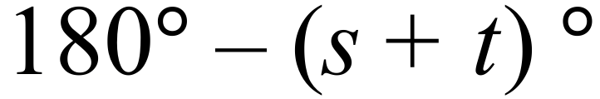

School Name
Mathematics Test 2017
Year 7 |  | Angle Properties | Calculator Allowed  Short Answer  Section
 |  |  | Name___________________
Answer all questions in the spaces provided on this test paper by:
Writing the answer in the box provided.
or
Shading in the bubble for the correct answer from the four choices provided.
Show any working out on this test paper. Calculators are allowed.
Which best describes the types of angles around point O.
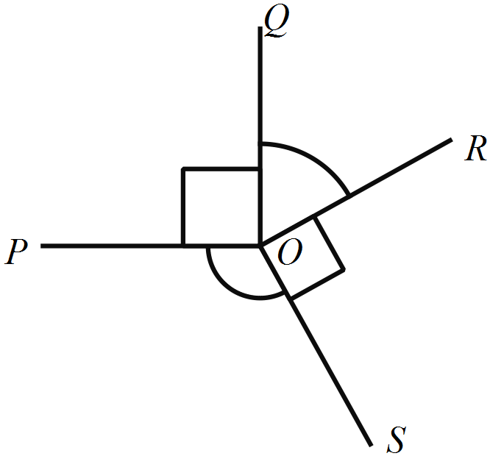

There are two acute angles, a right angle and an obtuse angle.
There are two acute angles, an obtuse angle and a reflex angle.
There are two right angles, an acute angle and an obtuse angle.
There are two right angles, an obtuse angle and a reflex angle.
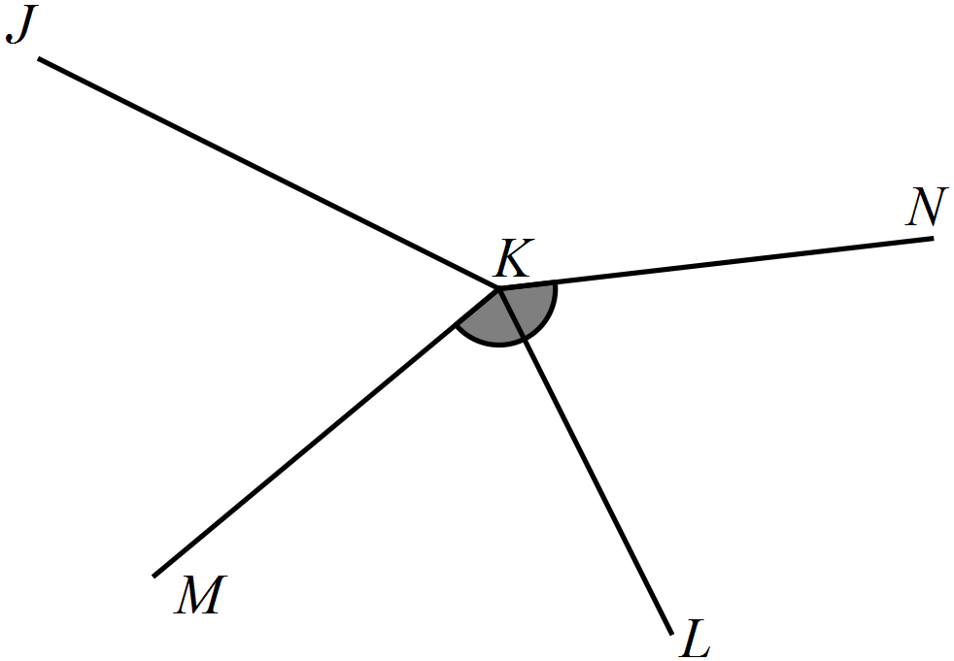What name could be used to describe the shaded angle?






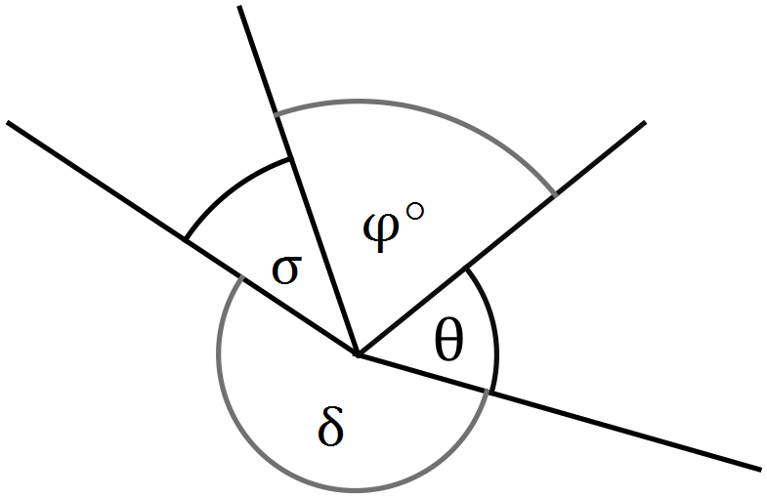Which of these angles is a reflex angle?

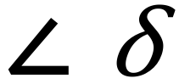
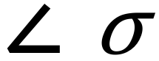
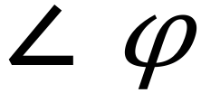


 | Which statement is true?
Which is true?
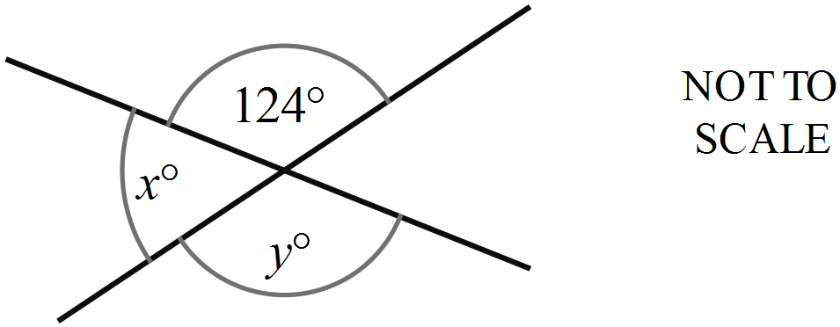
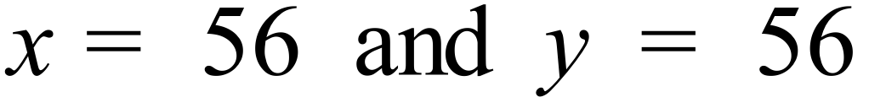
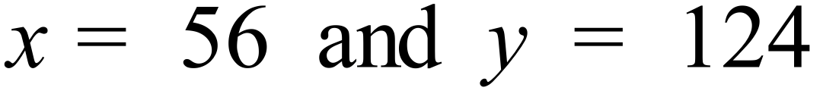
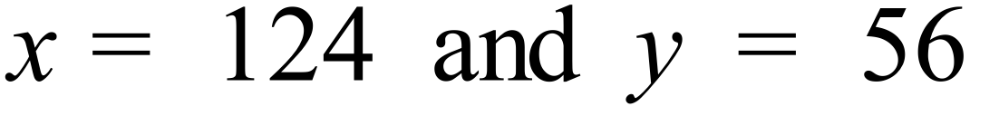
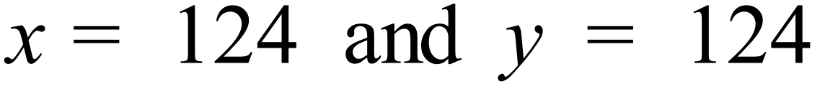
 | 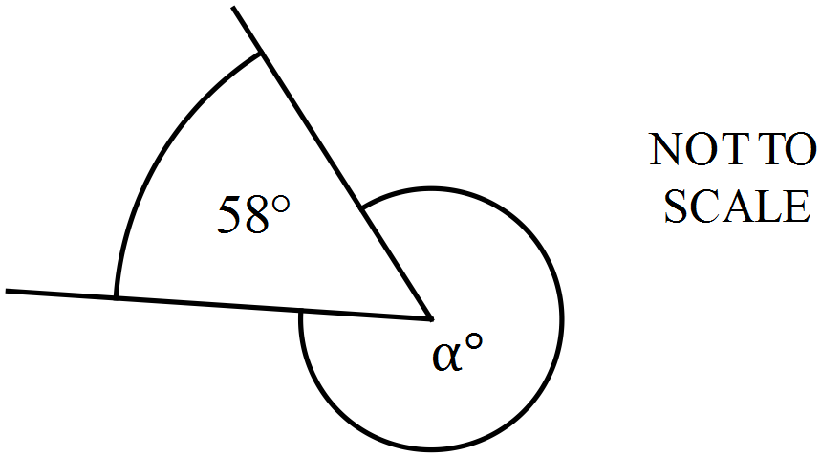What is the value of 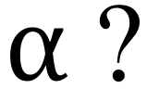
Which side is parallel to ED and perpendicular to BC?
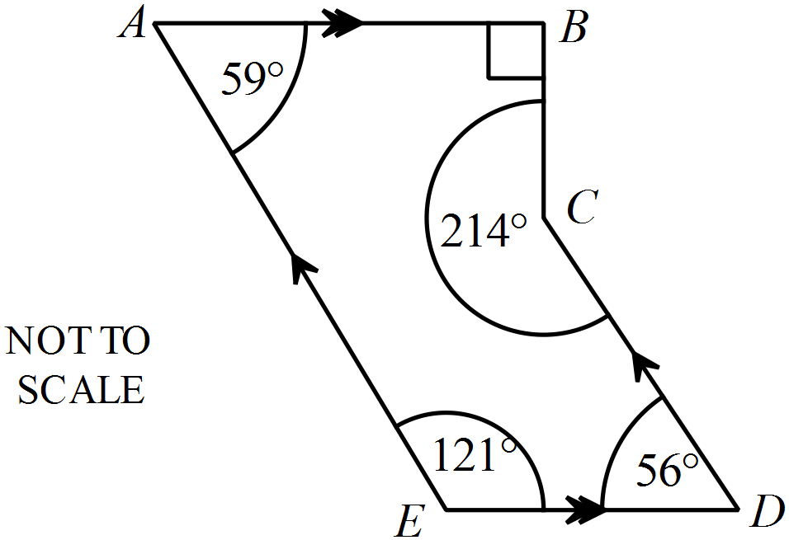
AB
AE
CD
DA

What is the value of z?
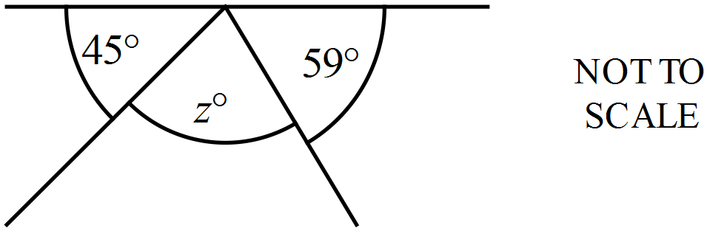

Which angle forms a pair of equal alternate angles with angle ?
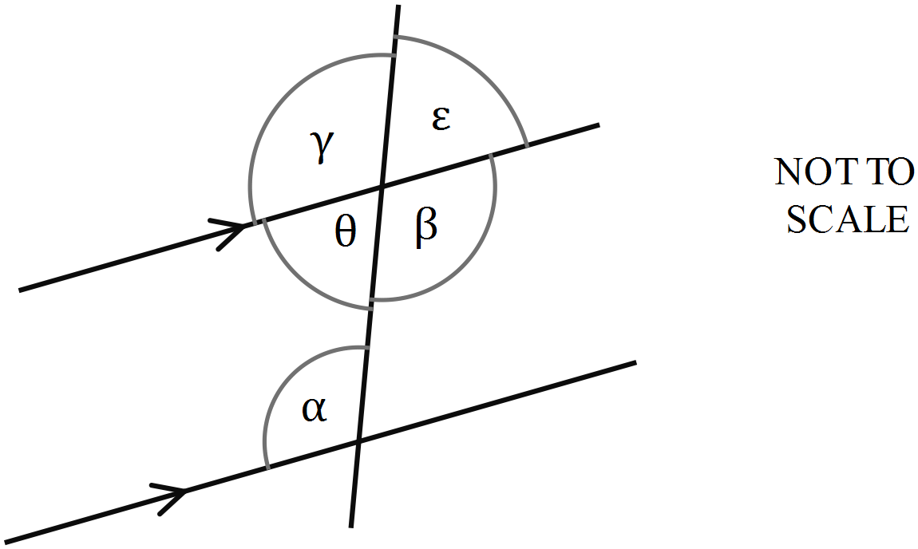

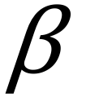
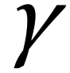
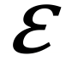
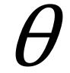

 | 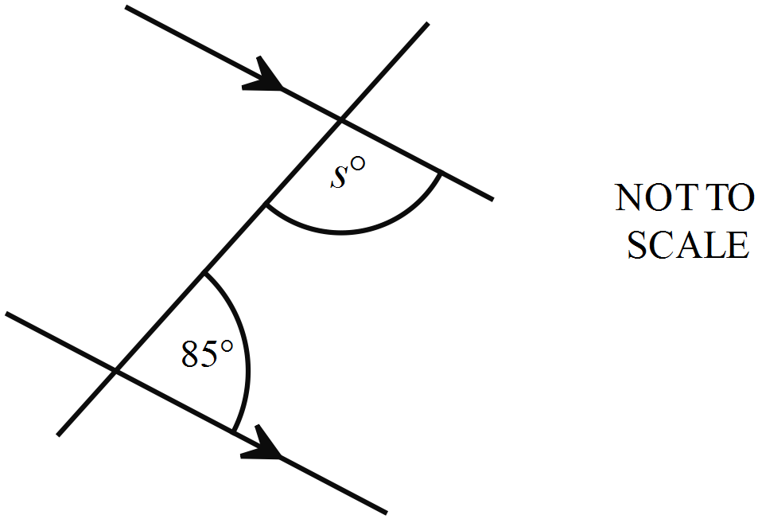Find the value of s.
The Holiday Hotel is a rectangular building on the corner of Breeze Boulevarde and Ocean Street.
What is the size the angle marked ?
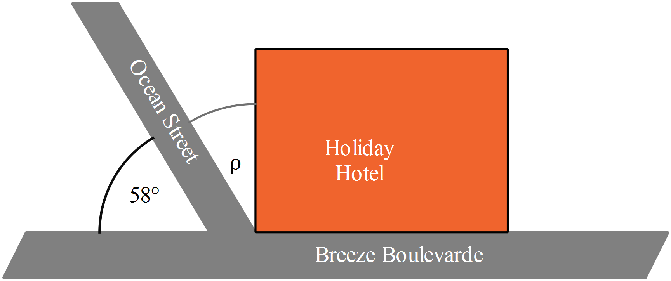
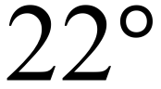
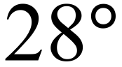
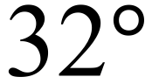
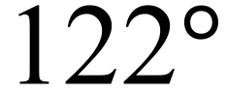

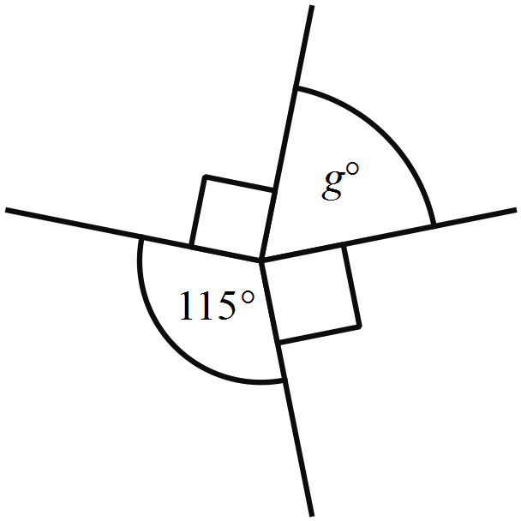What is the value of g?

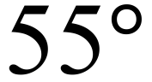
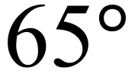
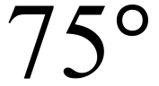
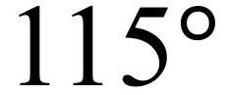

 | 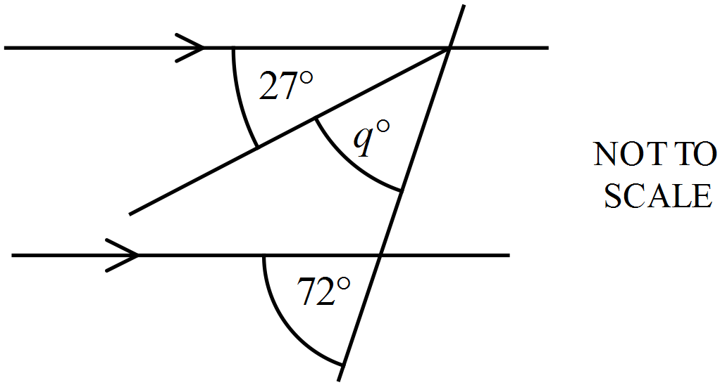What is the value of q?
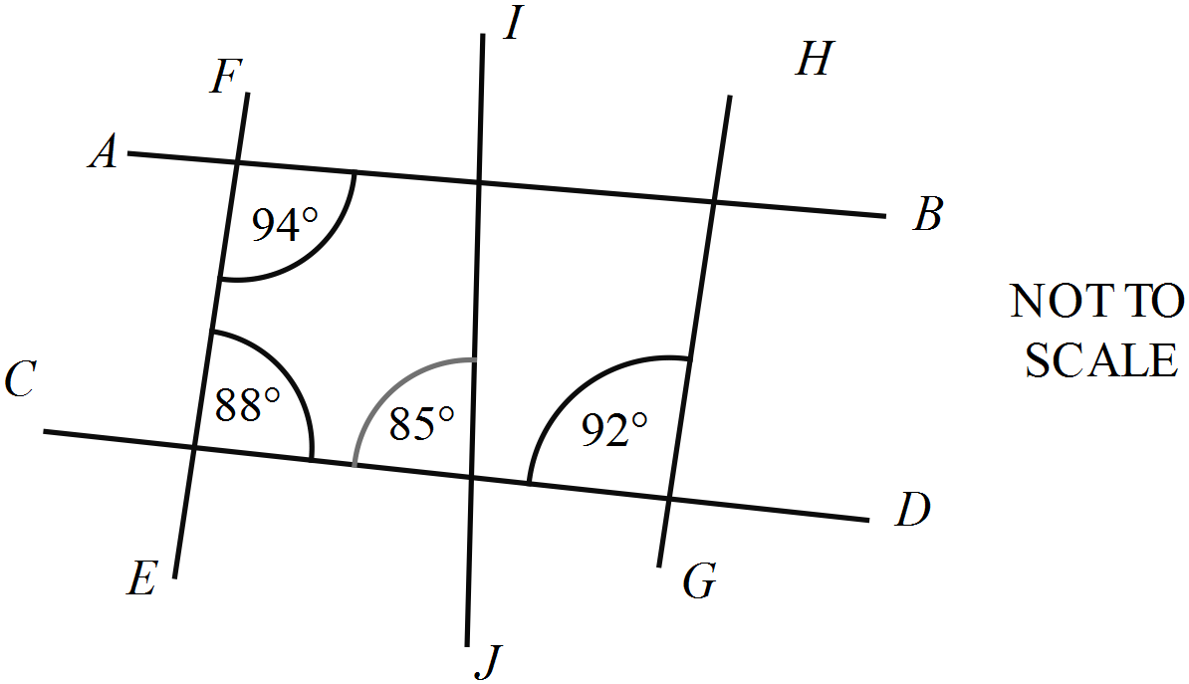Which lines are parallel?

AB and CD
FE and IJ
FE and HG
IJ and HG

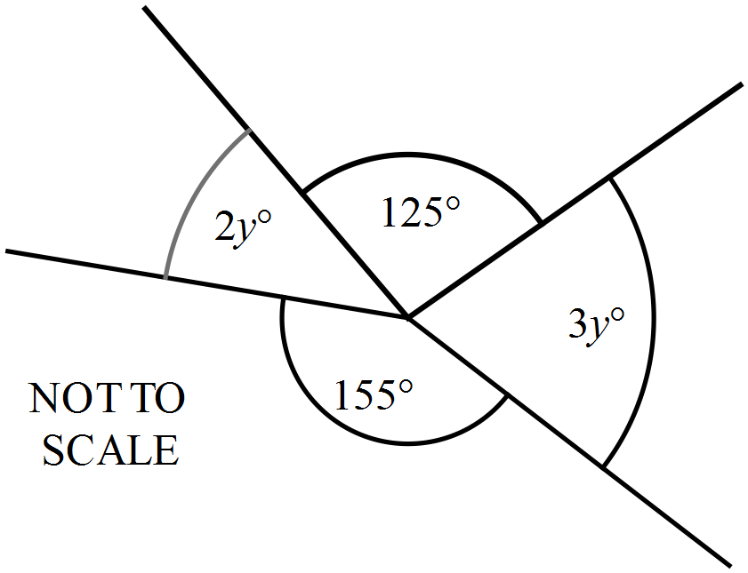 What is the value of y?

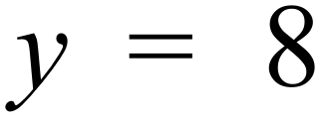
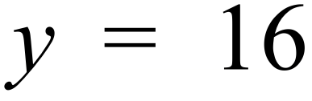
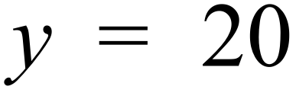
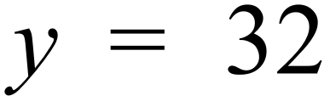

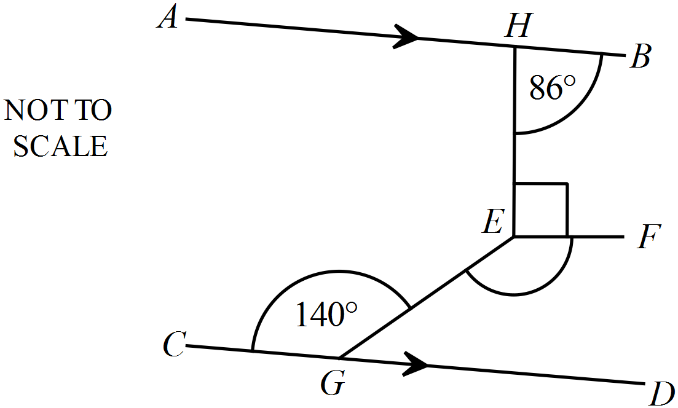AB || CD and 
What is the size of 

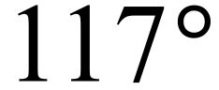
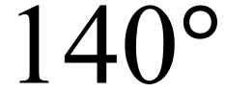
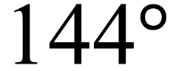
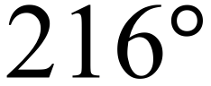

Write an expression for the size of  in terms of x.
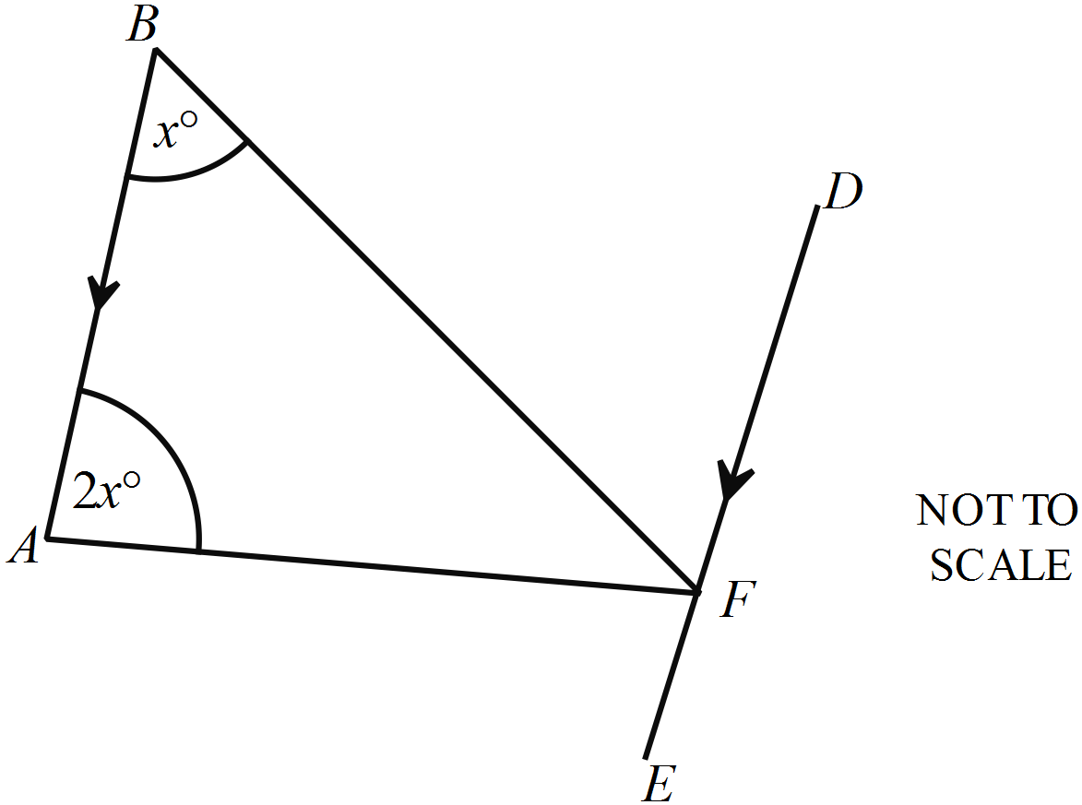

 | What is the value of p?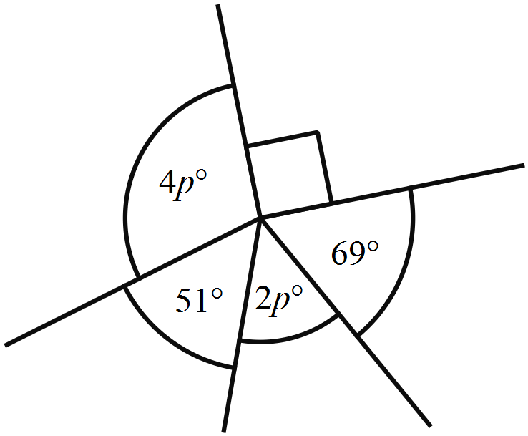
RS is parallel to YX.
Name an interval which is perpendicular to PQ.
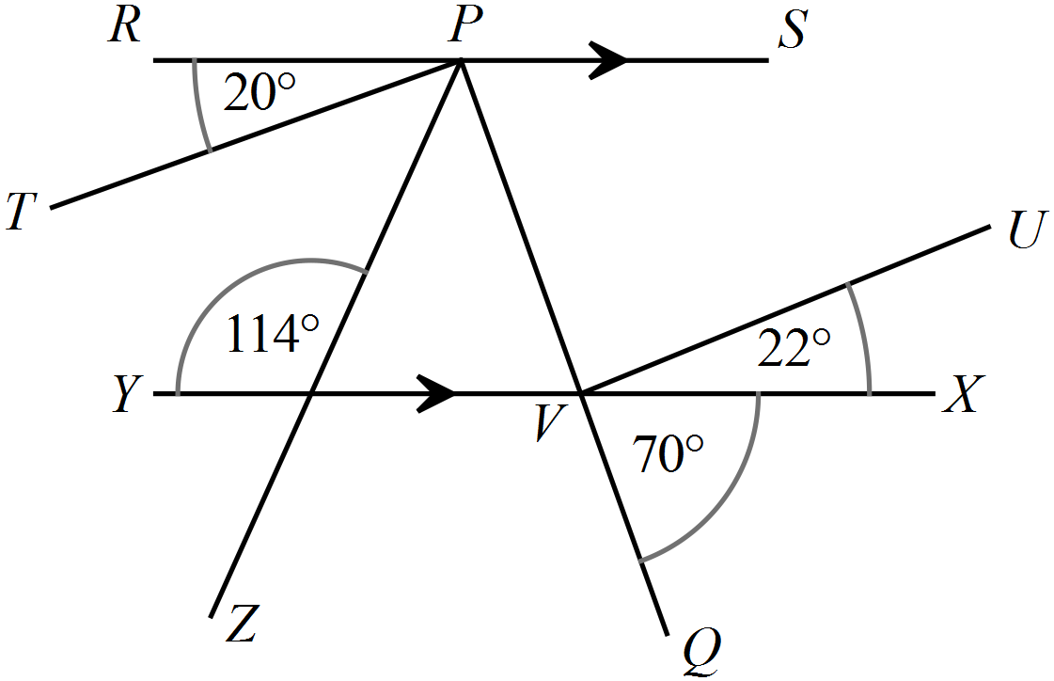

 | 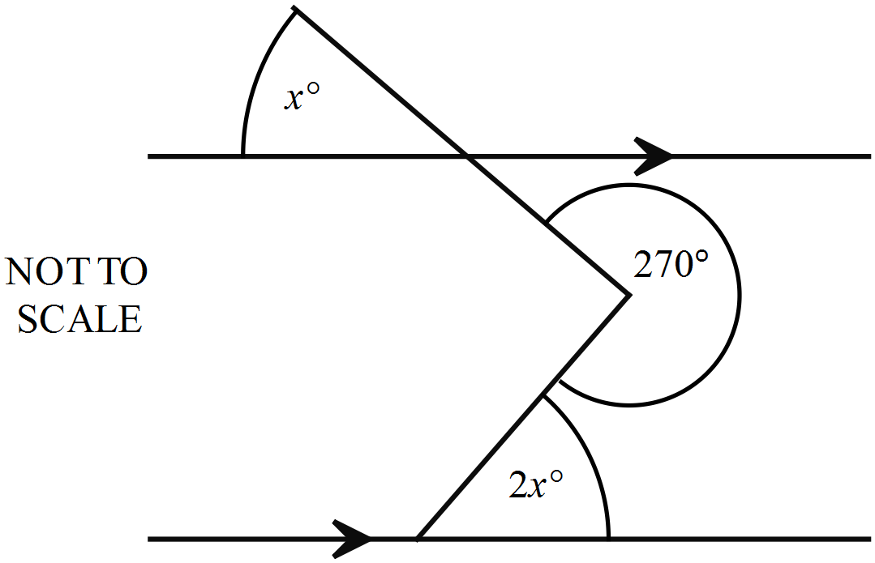What is the value of x ?

School Name
Mathematics Test 2017
Year 7 | Angle Properties | Non Calculator Section
ANSWERS

Question | Working and Answer
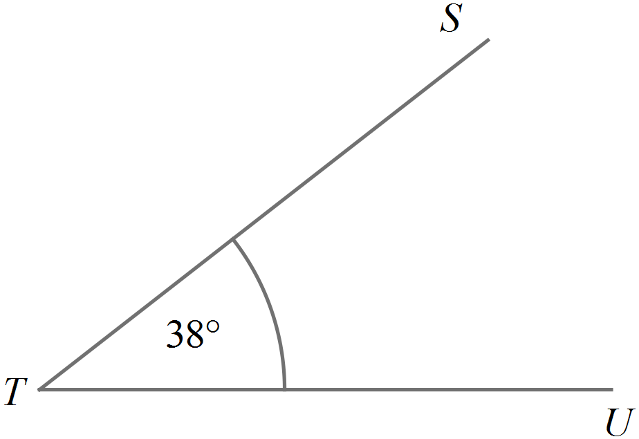

Accurately drawn and labelled ngle
 | 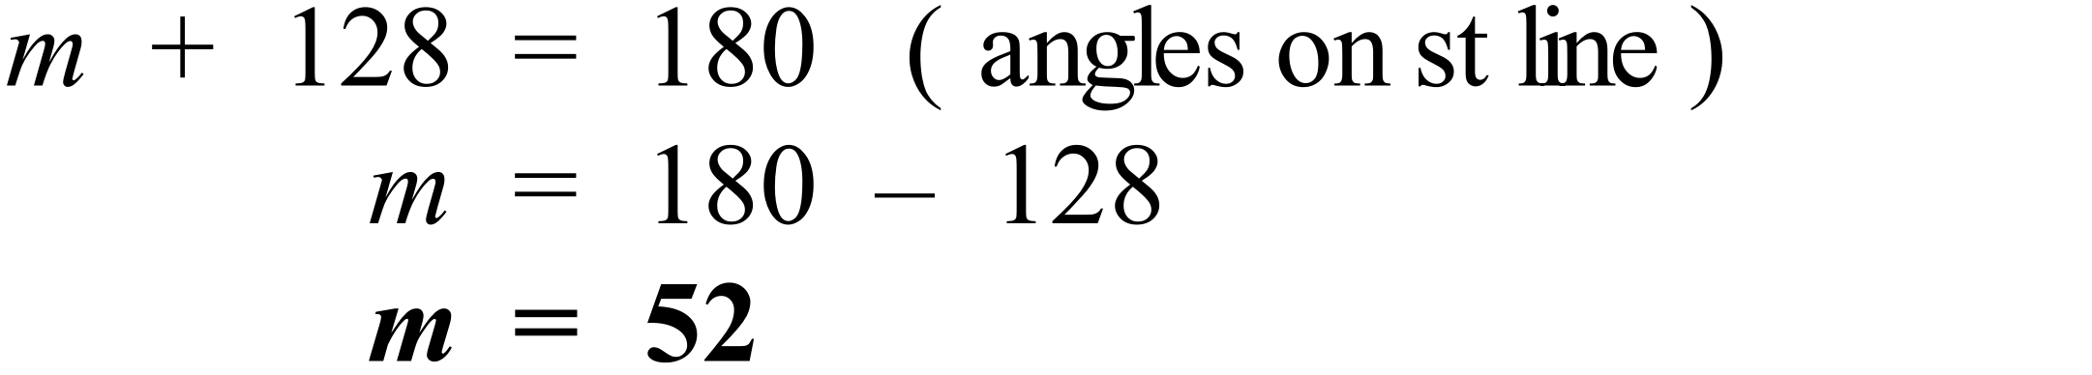
 | 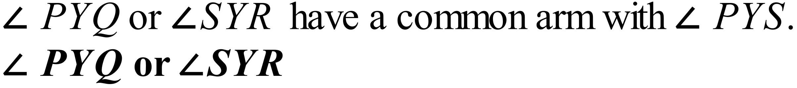
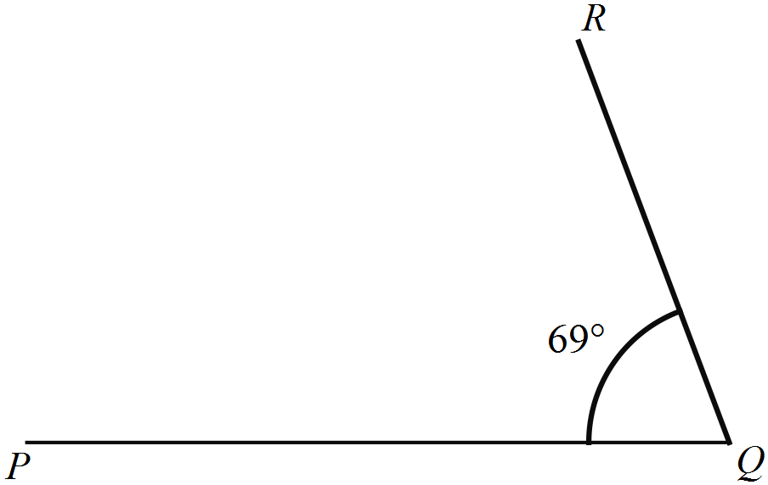

Allow one degree either way.
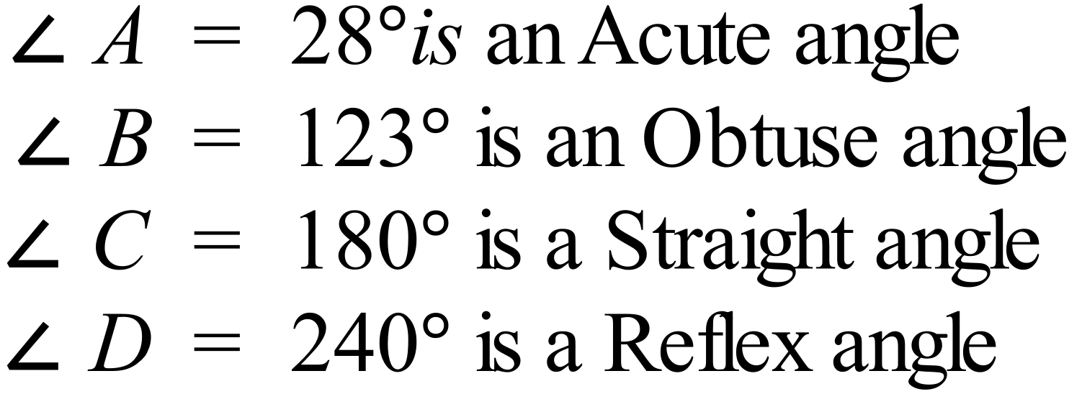
Only the first statement is correct
1st Answer
 | 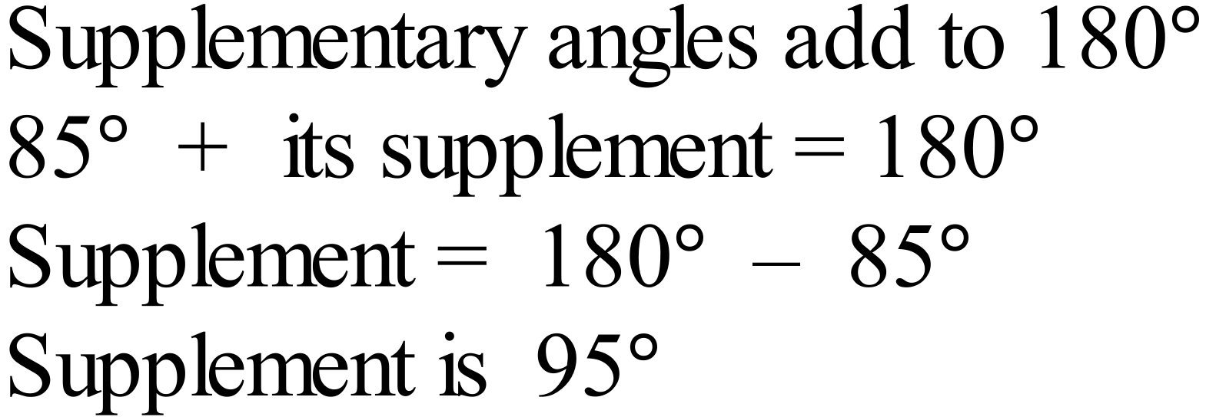
HE and EF
or HE and HD
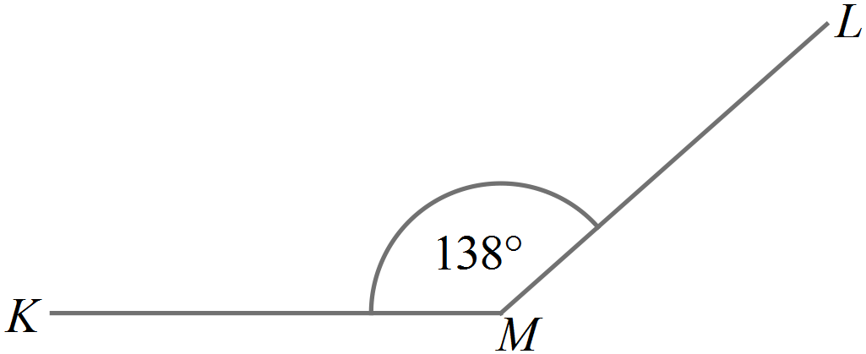

Allow one degree either way.
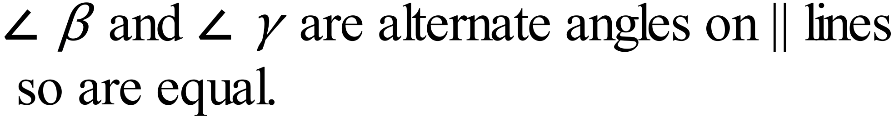
3rd Answer
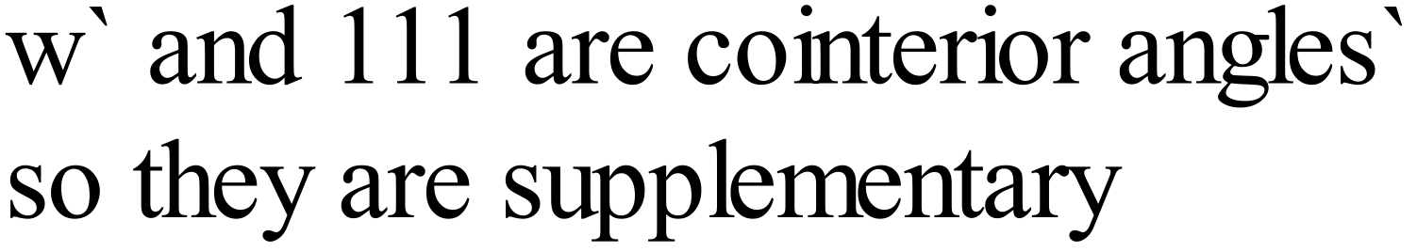
Supplementary cointerior angles on parallel lines
4th Answer
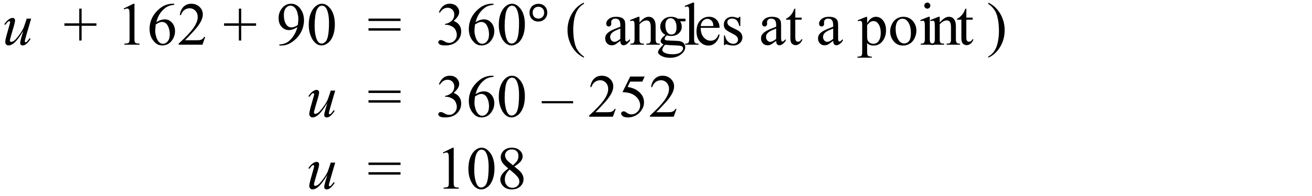
2nd Answer
 | 116º
 | 1st Answer
 | 3rd Answer
 | 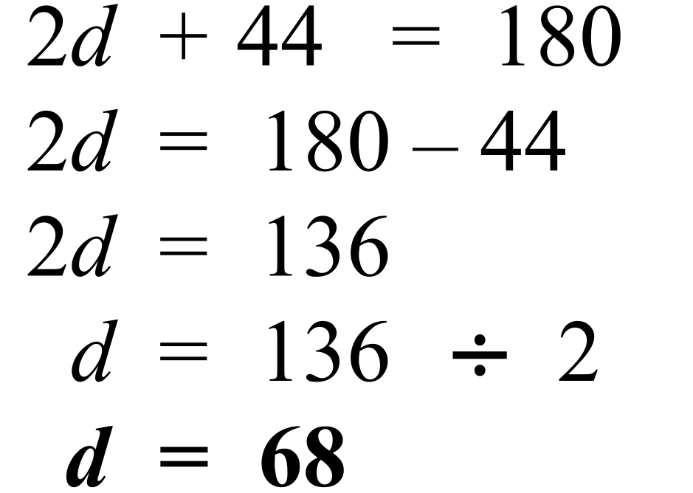
 | 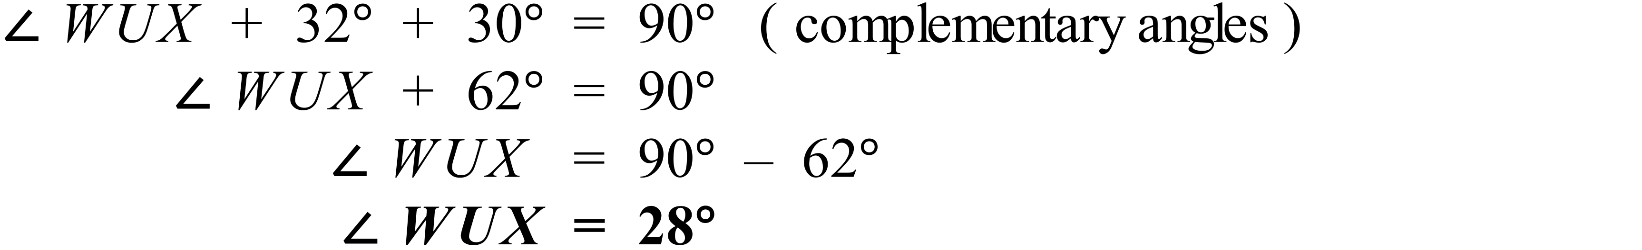
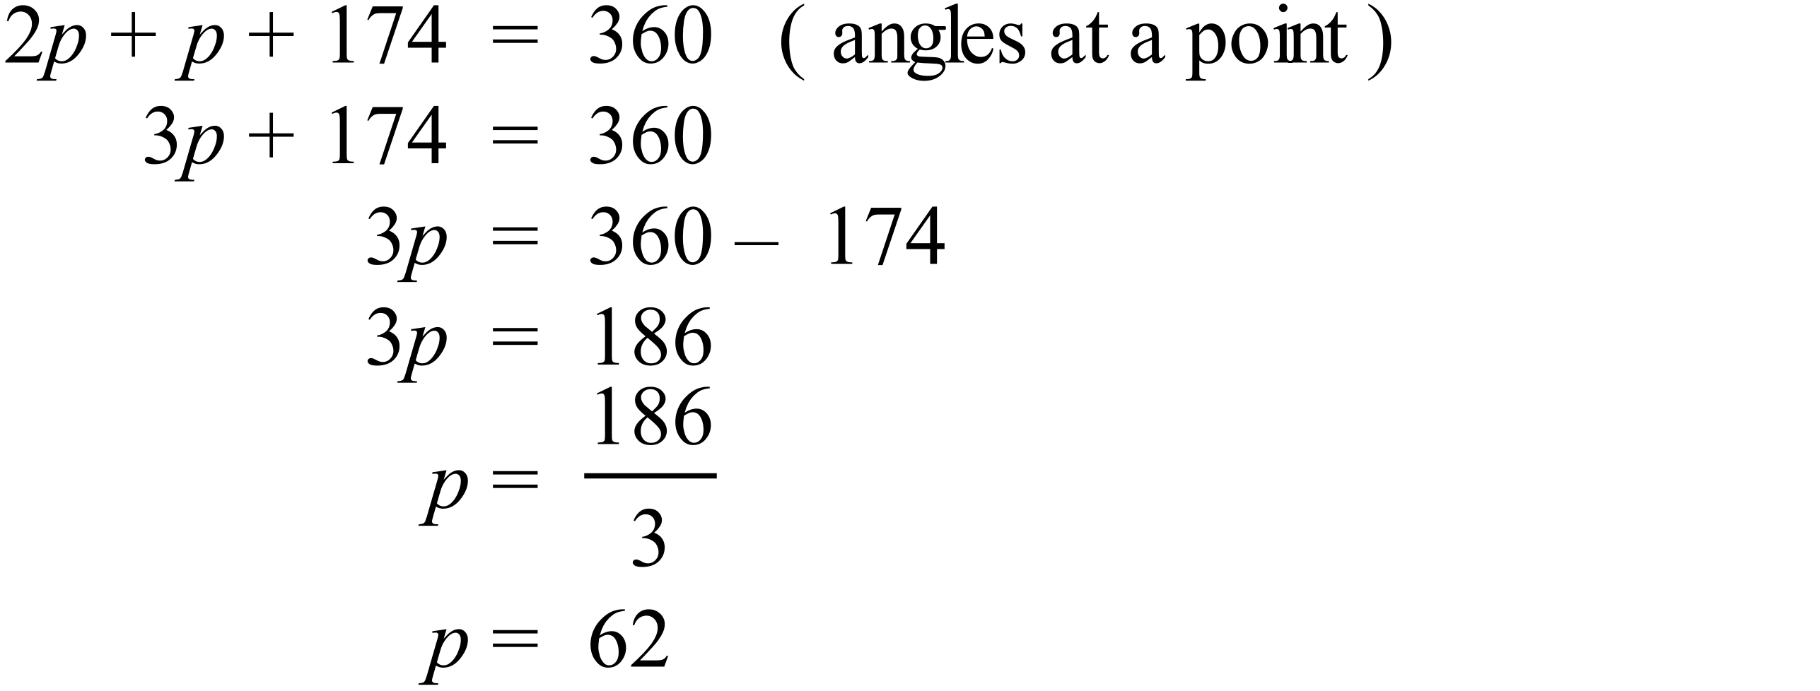
2nd Answer
 | Different methods are possible (2 shown).  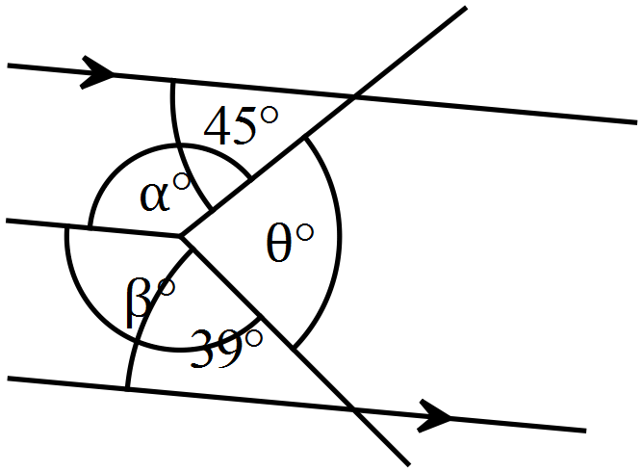  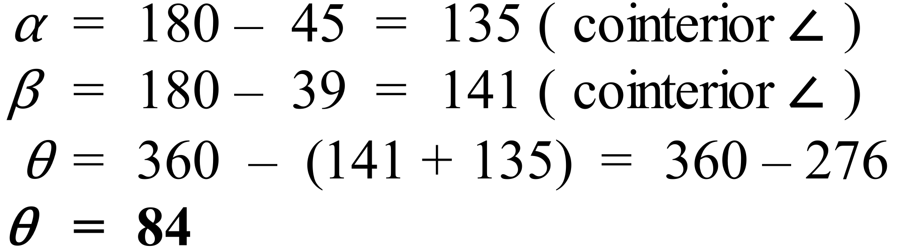 | 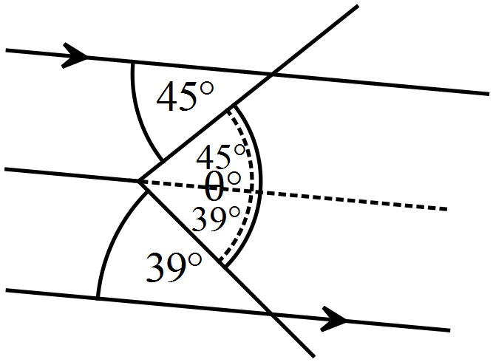  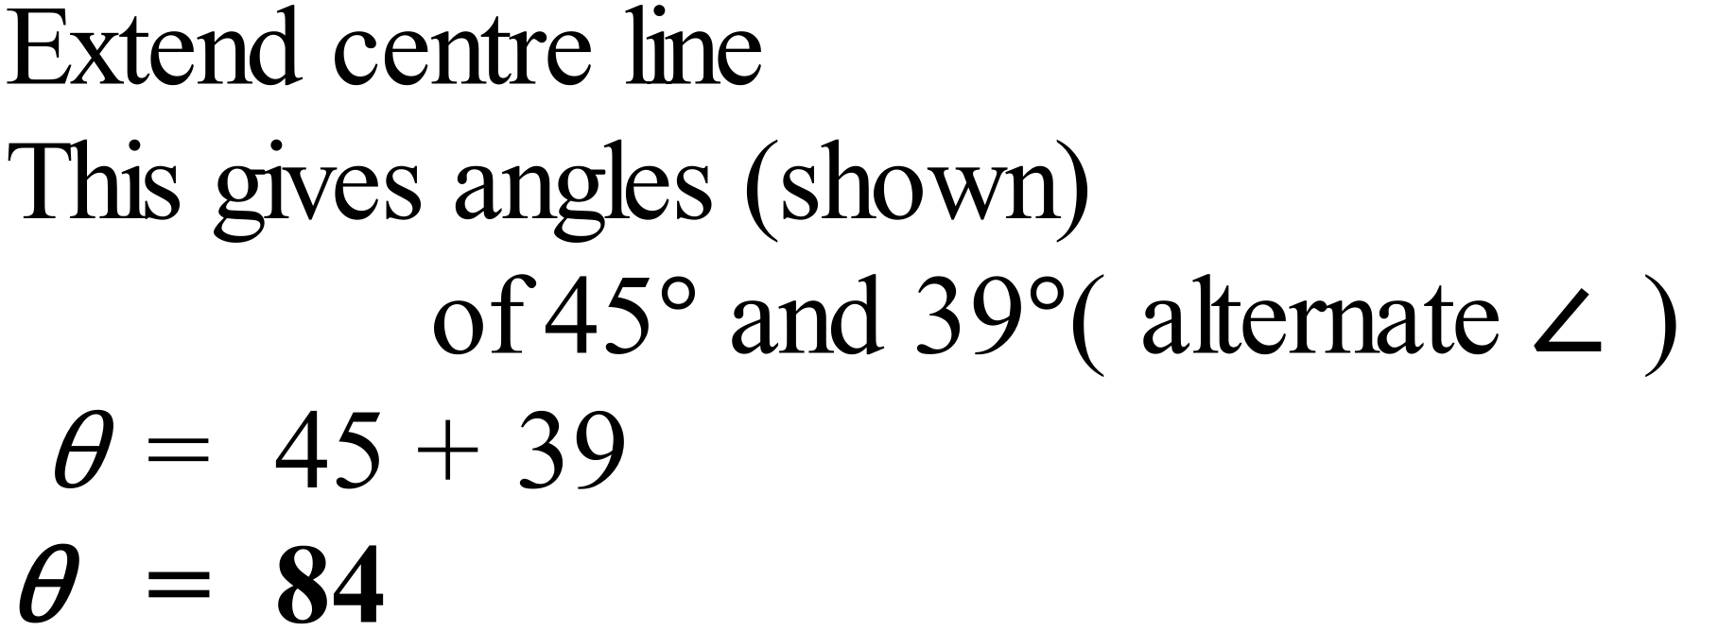
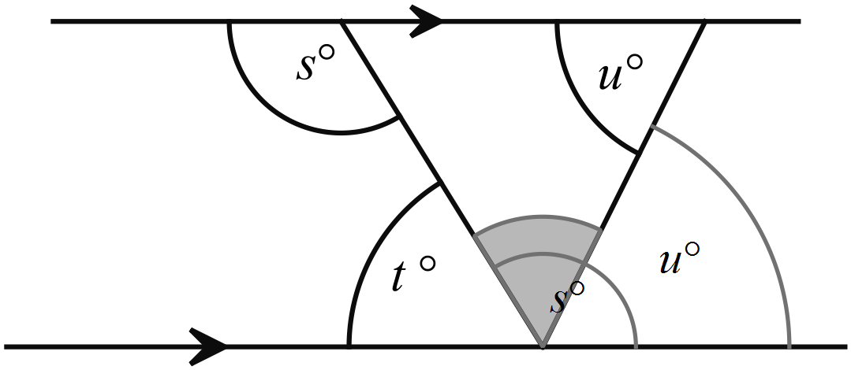

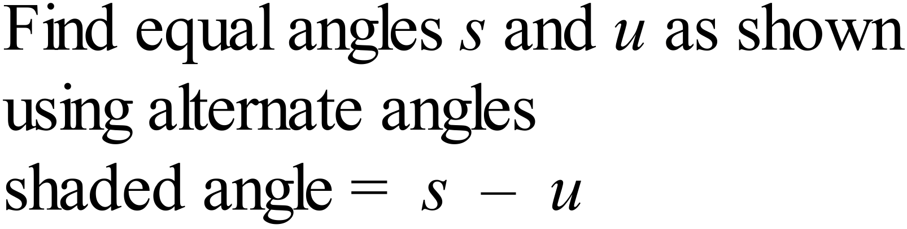
3rd Answer

School Name
Mathematics Test 2017
Year 7 | Angle Properties | Calculator Allowed  Short Answer  Section

ANSWERS
Question | Working and Answer
 | 3rd Answer
is the shaded angle
4th Answer
 | 1st Answer
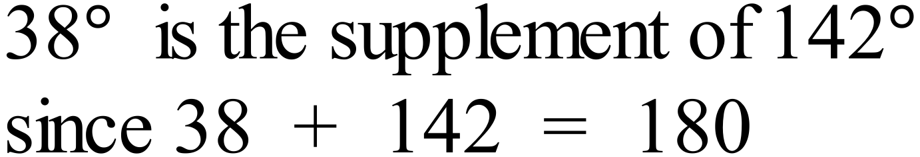
2nd Answer
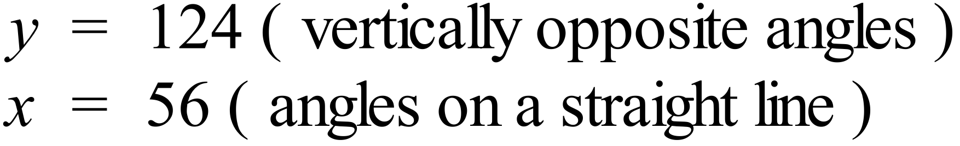
2nd Answer
 | 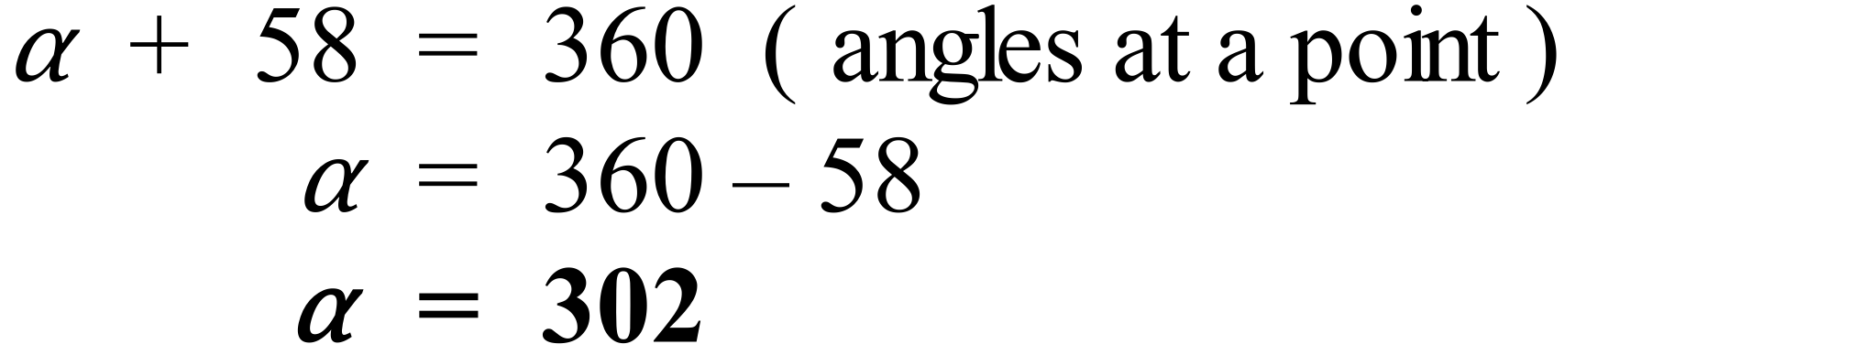

1st Answer
 | 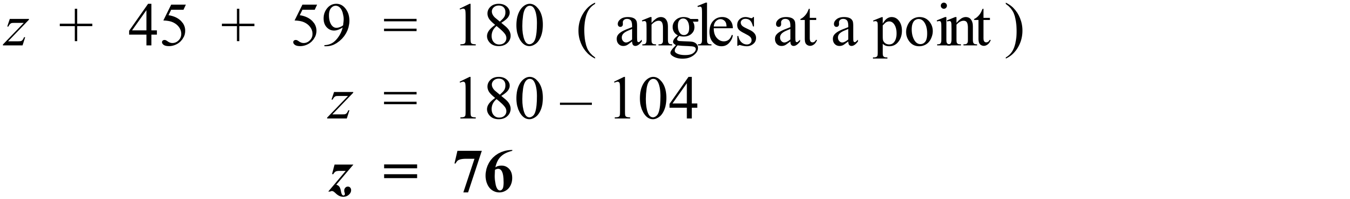
 | 1st Answer
 | 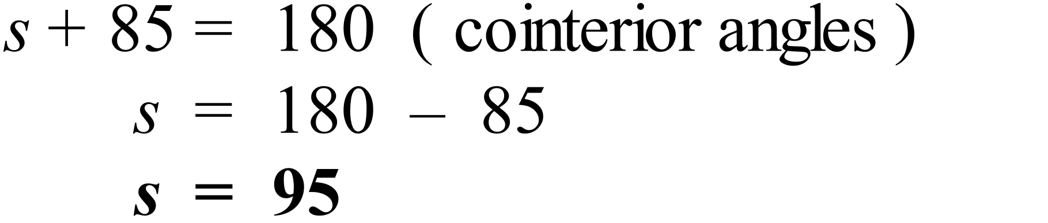
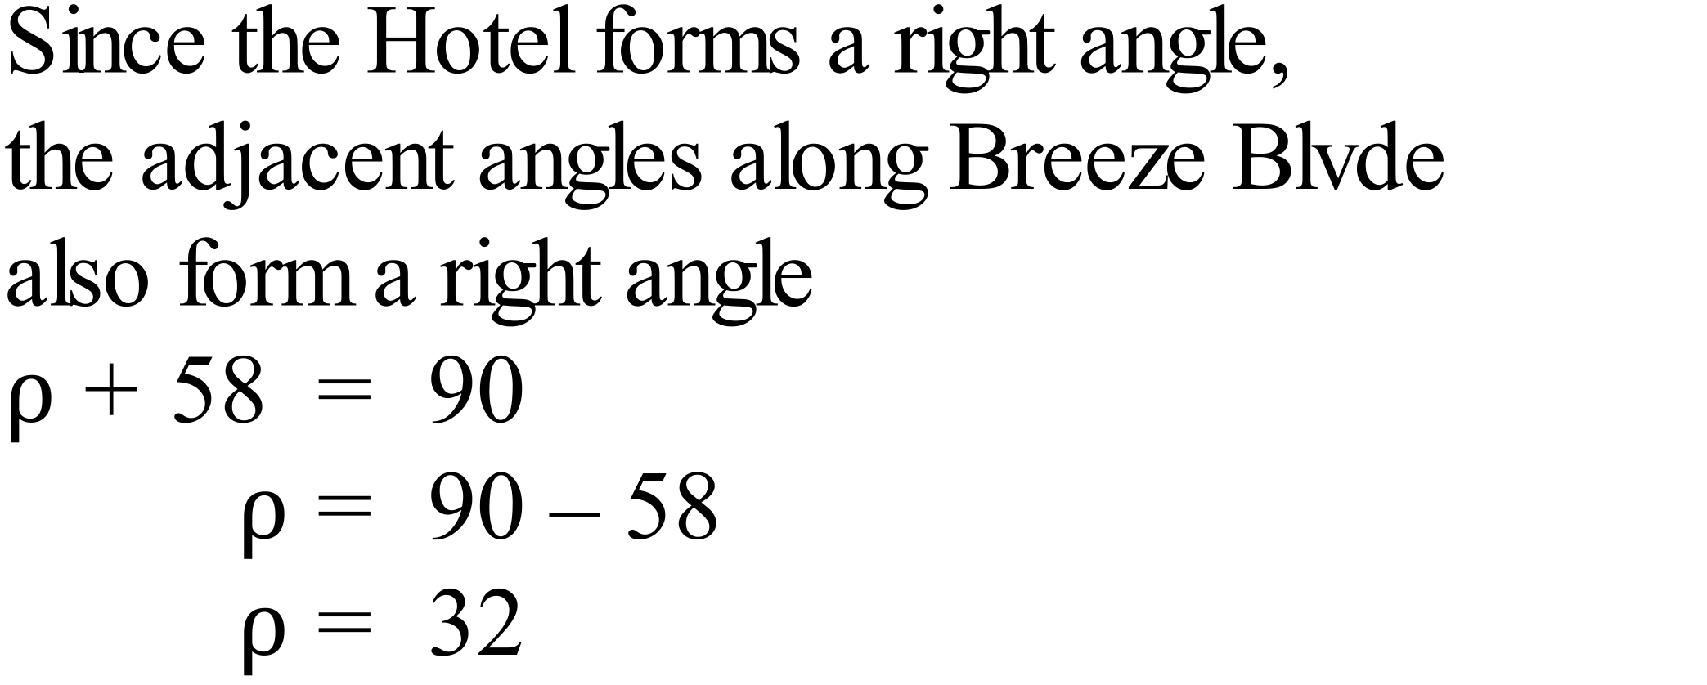
3rd Answer
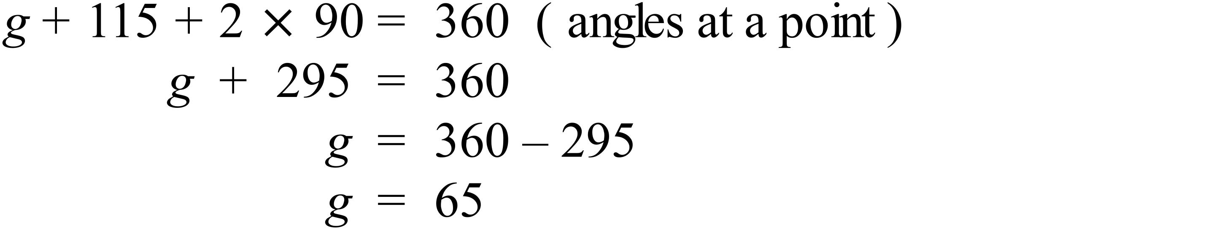
2nd Answer
 | 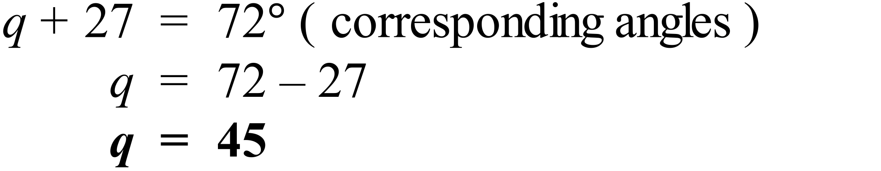
Between FE and HG there are a pair of cointerior angles that are supplementary (88º and 92º) so they are parallel.
3rd Answer
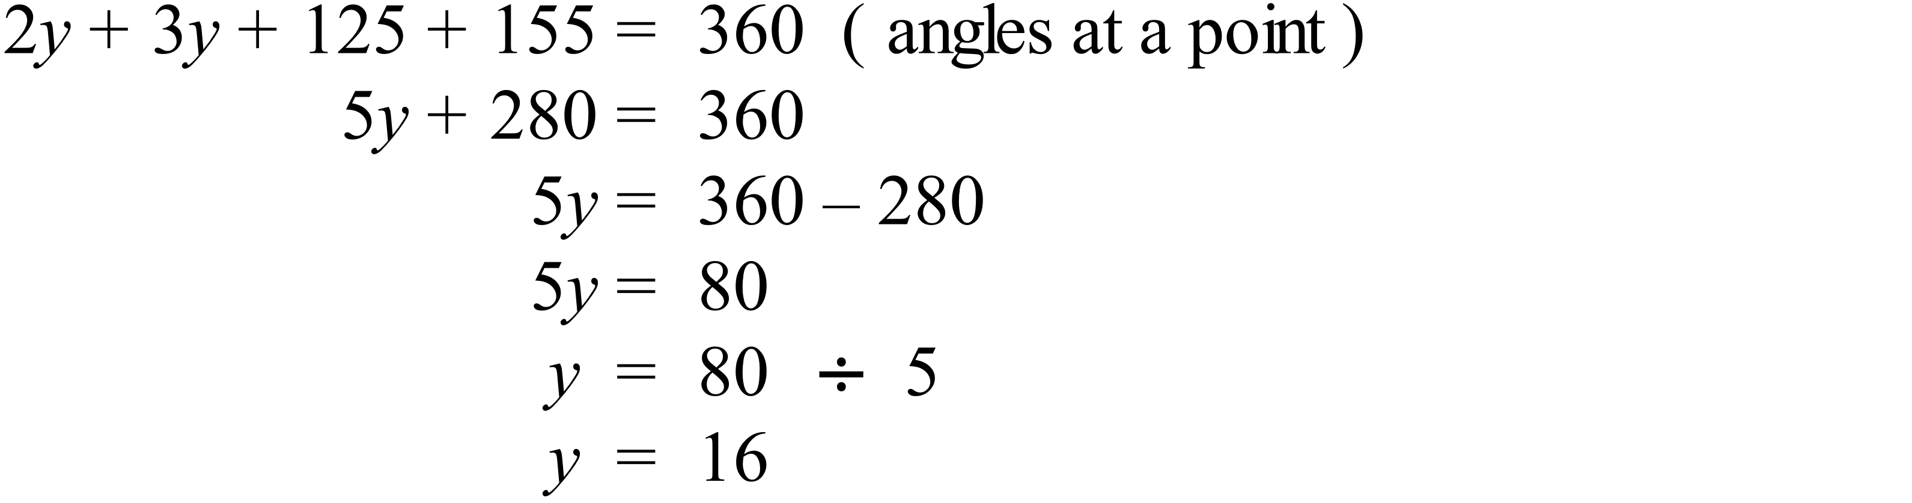
2nd Answer
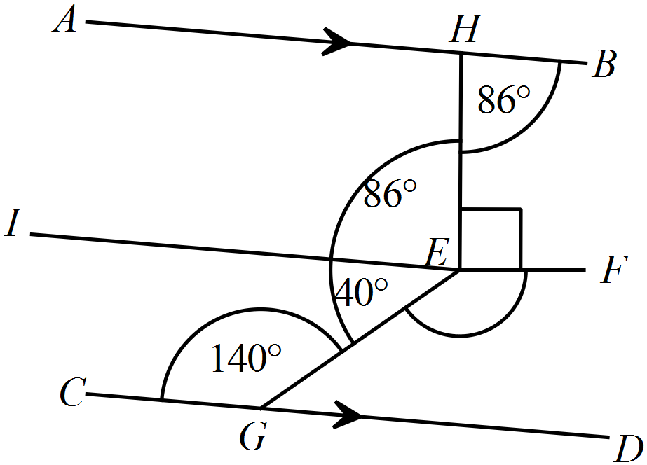

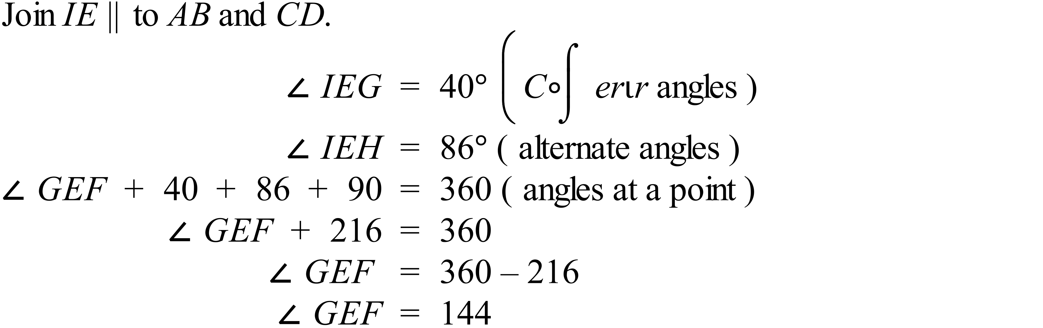
3rd Answer
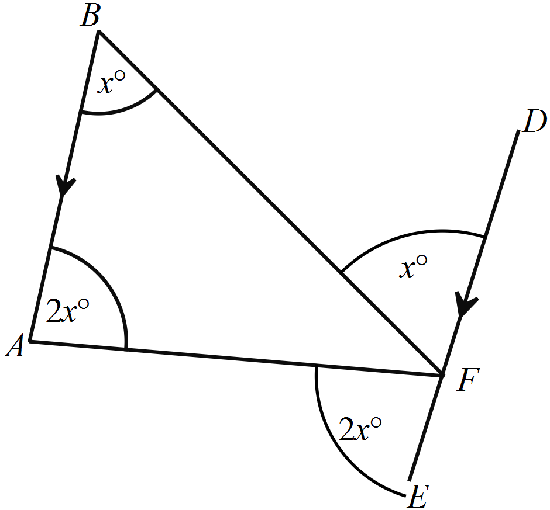

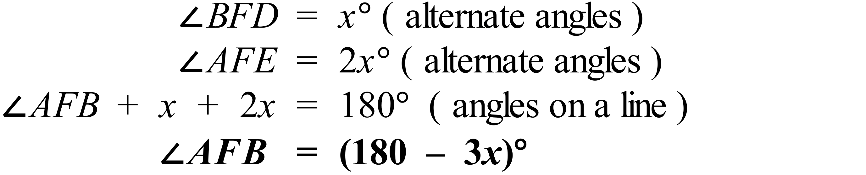
 | 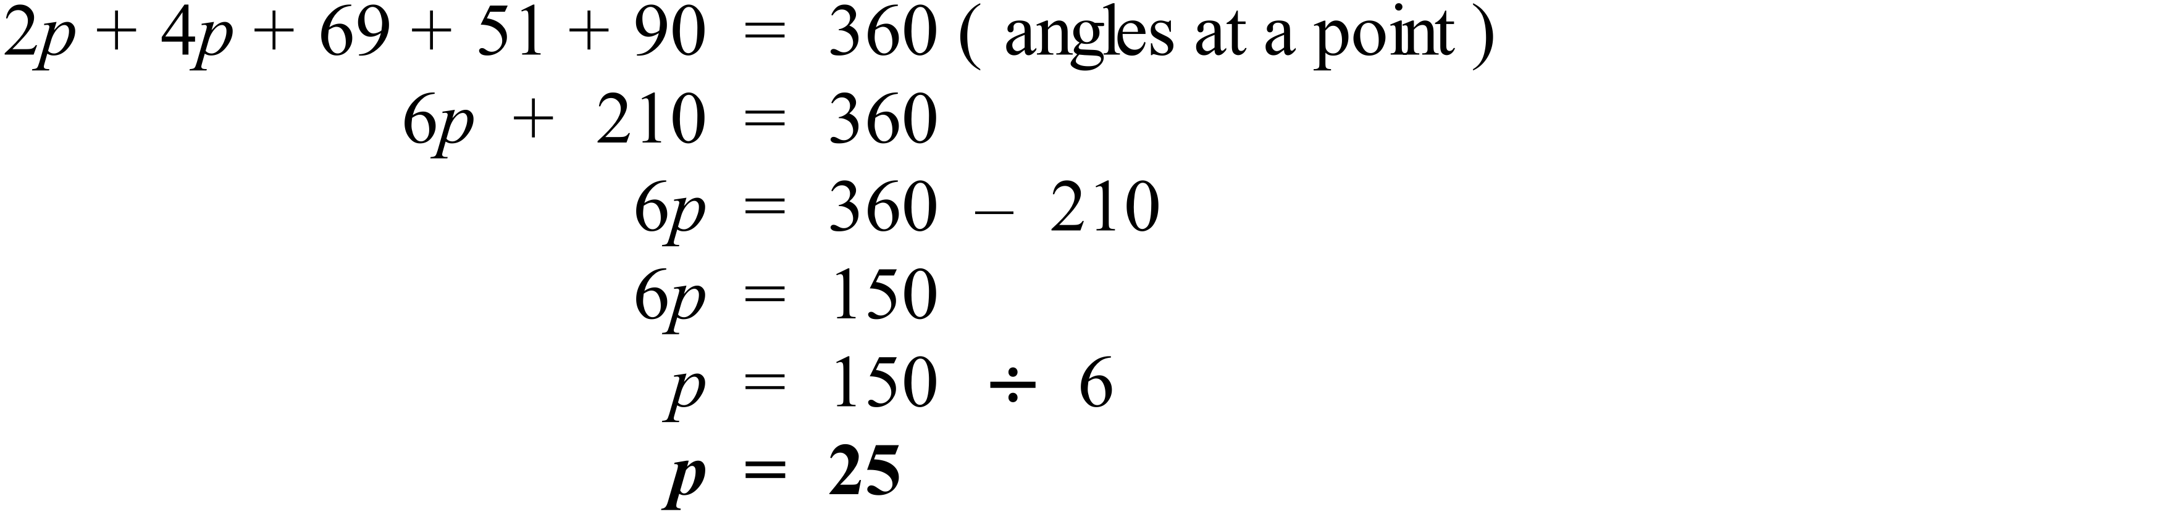
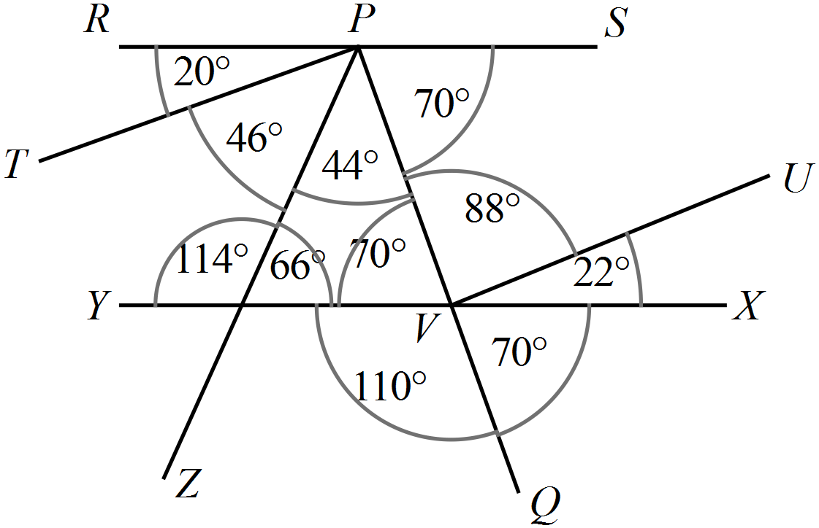

Resolving all of the angles around the segment PQ gives the diagram above.

So the line perpendicular to PQ is TP.
